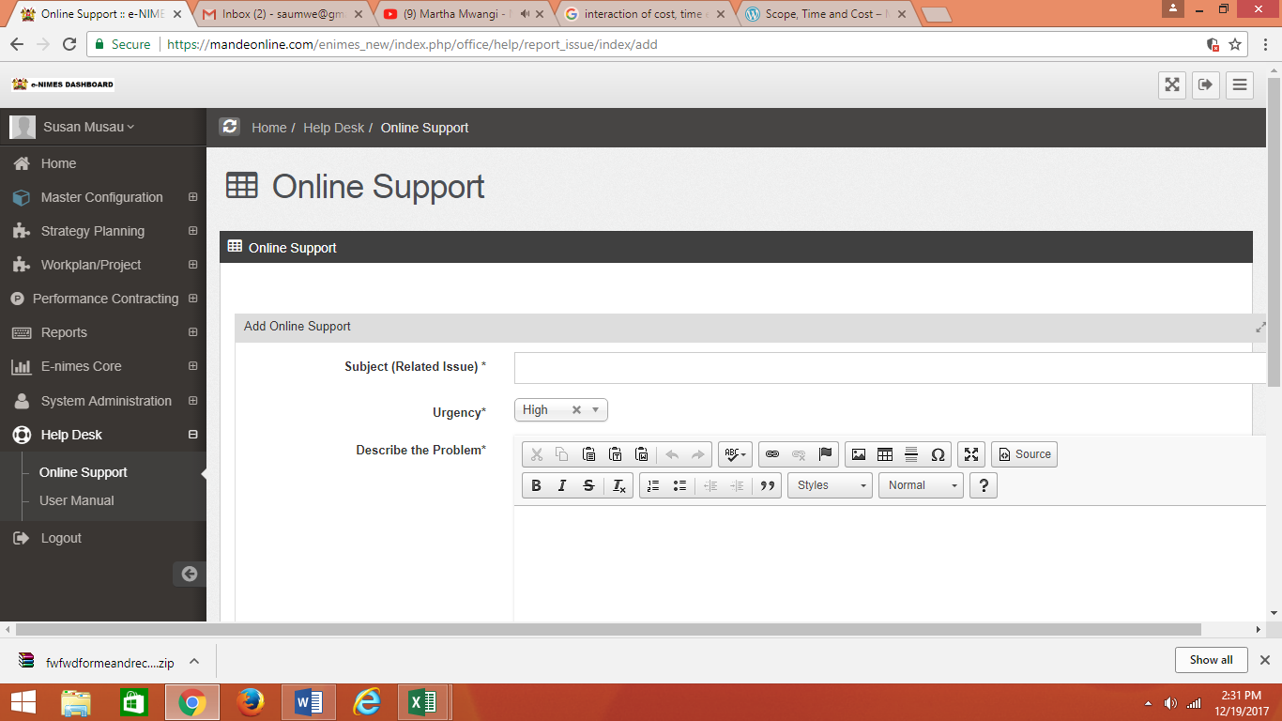

Here is the print screen of the error I am receiving

